- Create a simple cloud software application for Library book reservation system for SIMATS library using any Cloud Service Provider to demonstrate SaaS.

Aim
To create a simple cloud-based Library Book Reservation System for SIMATS Library using a Cloud Service Provider and demonstrate the Software as a Service (SaaS) model.

Procedure
- Log in to a cloud platform (AWS, Azure, or Google Cloud).
- Create a simple library book reservation application.
- Add book details such as title, author, and availability.
- Store book and student reservation data in a cloud database.
- Deploy the application on the cloud.
- Access the application through a web browser and test the book reservation process.
Flow chart
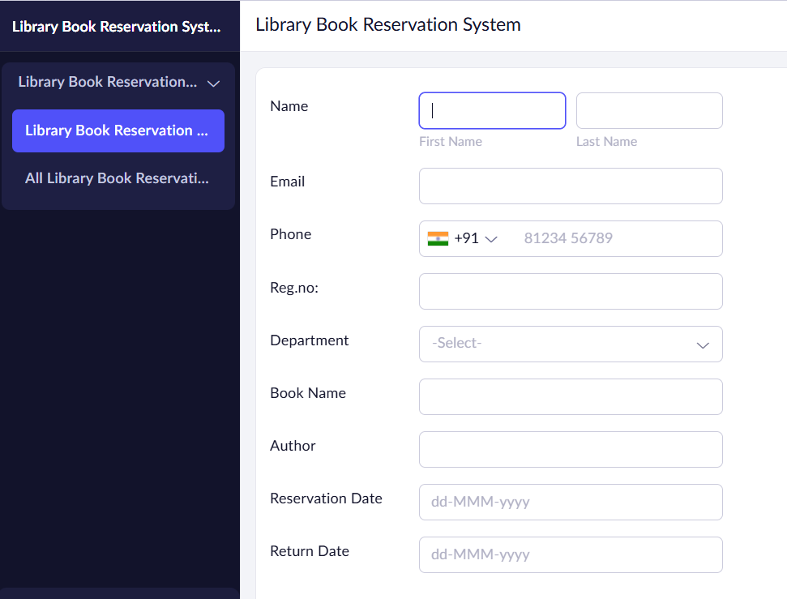

Result
The Library Book Reservation System for SIMATS Library was successfully developed and deployed on the cloud. Users can search for books and reserve them online, demonstrating the SaaS model.

